# Machine Learning Model Tracking Document

## 1. Dataset Information

|  |  |
| --- | --- |
| Dataset Name: | Well 1225 |
| Number of Samples: | 1225 |
| Number of Features: | 4 (Tf, Rs, Gg, Api) |
| Target Variable: | Pb |
| Outlier Handling: | None |
| Feature Engineering Applied: | None |
| Scaling/Normalization Applied: | None |
| Encoding Applied: | None |

## 2. Preprocessing Steps

|  |  |
| --- | --- |
| Step | Description |
| Train-Test Split | 70% - 30% |
| Shuffling | Yes, using random_state=42 |
| Handling Missing Data | None |
| Feature Scaling | SVM Only |
| Feature Selection | None |

## 3. Models Used & Hyperparameters

|  |  |  |
| --- | --- | --- |
| Model | Hyperparameters | Training Time |
| Linear Regression | None | 0.0008 |
| Ridge Regression | alpha = 0.001 | 0.0011 |
| Lasso Regression | alpha = 0.001 | 0.0023 |
| Decision Tree | max_depth = 12 | 0.0032 |
| KNN | n_neighbors = 7 | 0.0009 |
| SVR | C = 100, kernel = linear | 32.7210 |

## 4. Evaluation Metrics

|  |  |  |  |  |  |
| --- | --- | --- | --- | --- | --- |
| Model | MSE | RMSE | MAE | R² Score | Adjusted R² |
| Linear Regression | 258256.3 | 508.189 | 348.429 | 0.8239 | 0.8219 |
| Lasso Regression | 258256.6 | 508.189 | 348.429 | 0.8239 | 0.8219 |
| Ridge Regression | 258256.7 | 508.190 | 348.430 | 0.8239 | 0.8219 |
| Decision Tree | 197204.6 | 444.077 | 255.040 | 0.8655 | 0.8640 |
| KNN | 276717.1 | 526.039 | 366.417 | 0.8113 | 0.8092 |
| SVR | 268059.6 | 517.745 | 329.692 | 0.8172 | 0.8152 |

## 5. Cross-Validation Summary (5-Fold)

|  |  |  |  |  |  |  |
| --- | --- | --- | --- | --- | --- | --- |
| Model | RMSE Mean | RMSE Std | MAE Mean | MAE Std | R² Mean | R² Std |
| Decision Tree | 409.140 | 42.540 | 256.751 | 17.748 | 0.8824 | 0.0260 |
| KNN | 513.670 | 25.454 | 367.940 | 9.634 | 0.8172 | 0.0194 |
| Ridge Regression | 526.882 | 63.120 | 358.851 | 21.284 | 0.8068 | 0.0425 |
| Lasso Regression | 526.883 | 63.120 | 358.851 | 21.284 | 0.8068 | 0.0425 |
| Linear Regression | 526.883 | 63.120 | 358.851 | 21.284 | 0.8068 | 0.0425 |
| SVR | 607.730 | 36.829 | 418.477 | 19.101 | 0.7448 | 0.0230 |

## 6. Visualizations

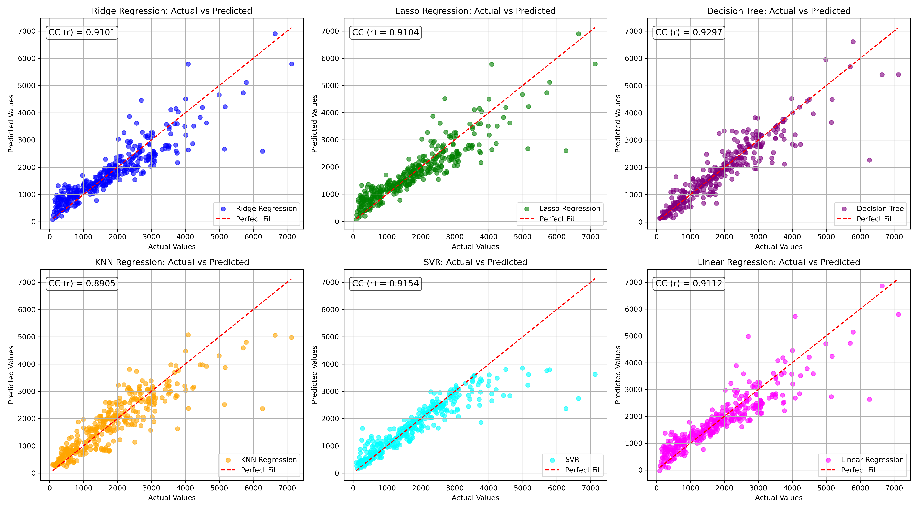

*Figure 1: Actual vs. Predicted Values for Pb (Well 1225)*

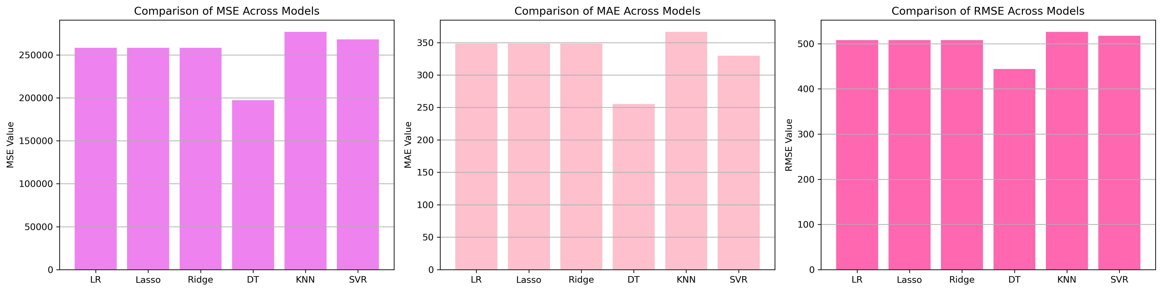

*Figure 2: Bar Charts of MSE, RMSE, MAE for Pb (Well 1225)*

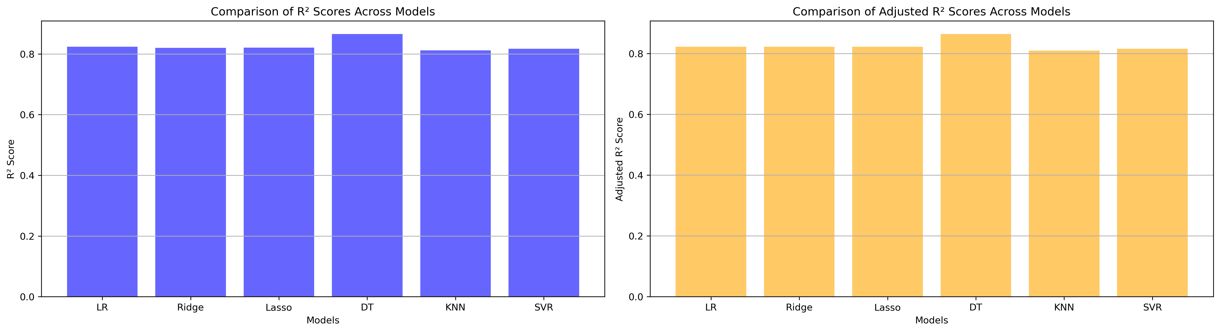

*Figure 3: Bar Charts of R² and Adjusted R² for Pb (Well 1225)*

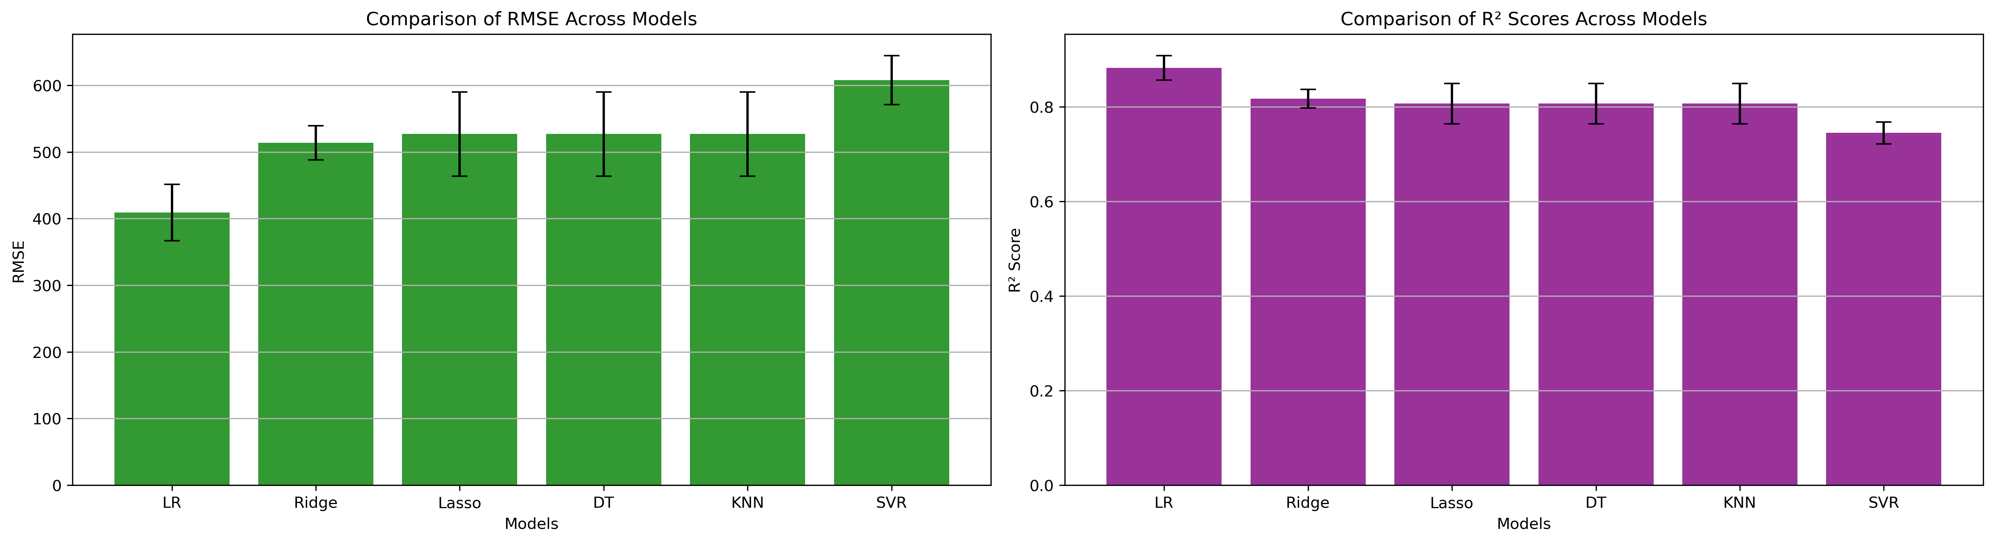

*Figure 4: Error Bars for RMSE and R² from CV for Pb (Well 1225)*

### 7. Observations & Next Steps

* **Best Performing Model**: Decision Tree (RMSE: ~444.08, R²: ~0.8655)
  + Linear, Lasso, and Ridge performed similarly
  + Decision Tree outperformed others on both test and CV
  + SVR showed poor results despite long training

### 8. Code Access

The complete source code for data preprocessing, model training, evaluation, and visualization is [available here.](http://github.com/BoushBoo/pvt-prediction-ml-/tree/main) The repository includes organized Jupyter notebooks for each phase, dataset, and target, as well as requirements for reproducibility.